Multimedia Project Documentation

**Team Members of:**

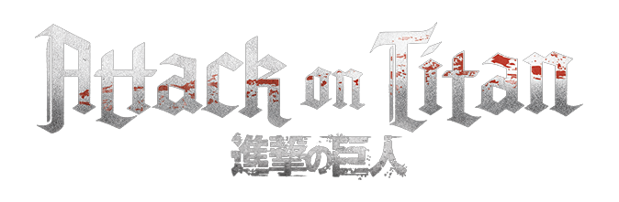

2022

**Project Link:** [**https://drive.google.com/drive/folders/1-tyuWS65b8vbp5myeTX3ND8euQRrLVGM?usp=sharing**](https://drive.google.com/drive/folders/1-tyuWS65b8vbp5myeTX3ND8euQRrLVGM?usp=sharing)

1) Serag Eldeen Ashraf Yehia Gouda _ 19-00717

2) Hossam Ayman Hasan El Badry _ 19-00417

3) Omar Alaa Eldeen Mohamed _ 19-00454

4) Mahmoud Ahmed Mahmoud Abdelgelel _ 19-00311

5) Abdelkhalek Mohamed Mahmoud _ 19-00395

6) Nagham Ahmed Mahmoud _ 19-01073

**CONTENTS**

2

3

[Game Introduction...................................................................................................................................](#Game Introduction)

3

9

10

10

11

AI ..............................................................................................................................

[Player.....................................................................................................................................](#The Player)

12

Attack .............................................................................................................................

Movement ...............................................................................................................................

[Game UI Elements.....................................................................................................................................](#Game UI Elements)

[Enemy...........................................................................................................................................](#The Enemy)

Animation ...............................................................................................................................

## **Game Introduction**

* The game is talking about a first-person shooter (FPS), and the goal of the player is to kill all the enemy monsters without taking too much damage and reach to the highest place of the game touching the flag to Win.
* If the player’s health drops to zero, then the player dies, and the game is over.
* As the game is an FPS the main camera is fixed at the eye level of the player throughout the game.
* The player has a variety of movements they can perform, and those movements will be described in this documentation.
* The player’s main attack weapon is a gun used to shoot the enemy.
* The Enemy models have their own animation that differs from state to state.
* The Enemy AI controls the enemy movement and reactions towards the player.

## **The Player**

# Movement:

Here is a list of all the movements the player can perform:

* Movement

* Jumping

* Sliding

* Wall running

* Grappling & Swinging

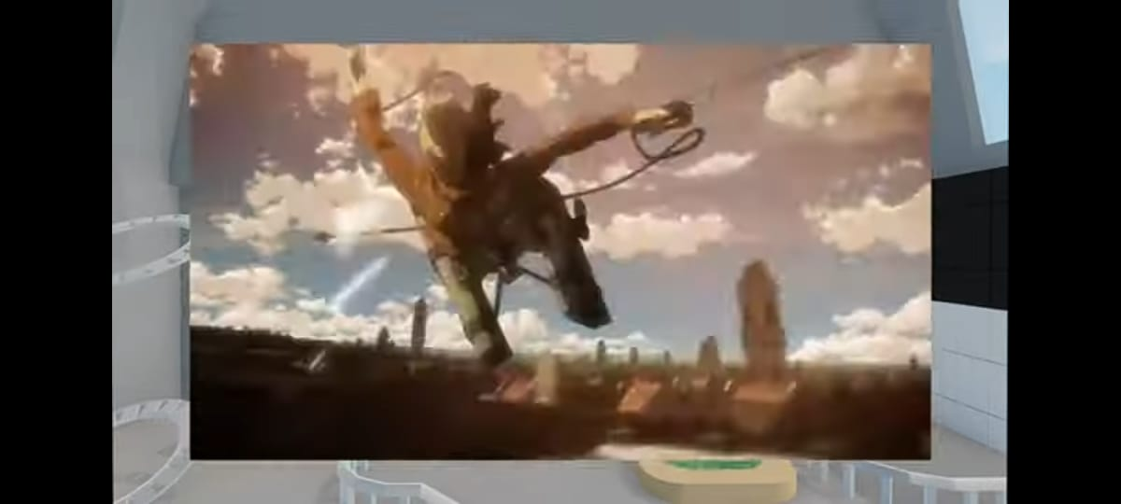

* Climbing

* Ledge Grappling

* Crouching

* Some of Advancing Movement Sloping

# Attack:

* The player owns a set of weapons such as:

1. Carbine
2. Shotgun
3. Pistol

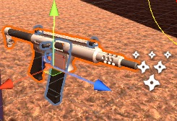

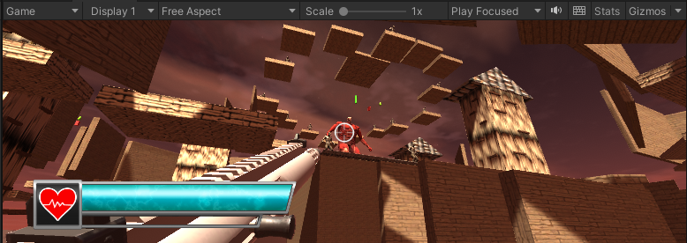

## The Enemy

# Animation:

**The animation is consisting of the following stats:**

* For locomotion: idle and walking
* For attacks: hand swing and foot stomp
* Death animation
* Damage taken animation

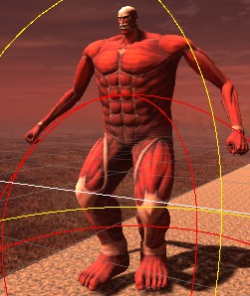

# AI:

The Enemy AI using the **Nav Mesh Agent** that give the enemy ability to track the player in the blue region and also limit the enemy movement within the boundary given its radius and height and the jump distance and able to climb on objects 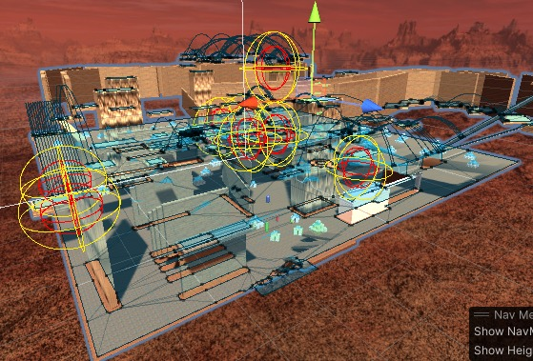

## Game UI Elements

# Player Health Bar:

Measures the player health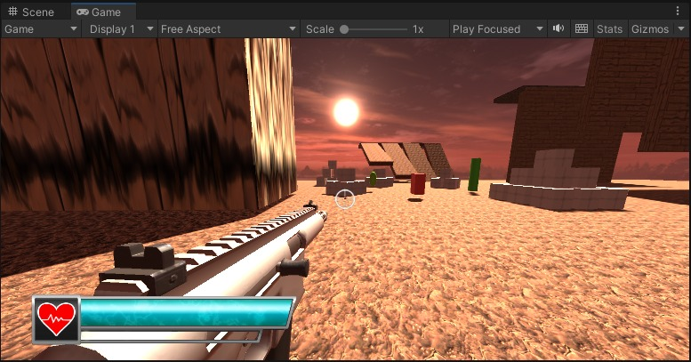

# Game over screen:

